July Monthly Report

Zihan Qiao (Weibo)

### The workflow of Weibo in July

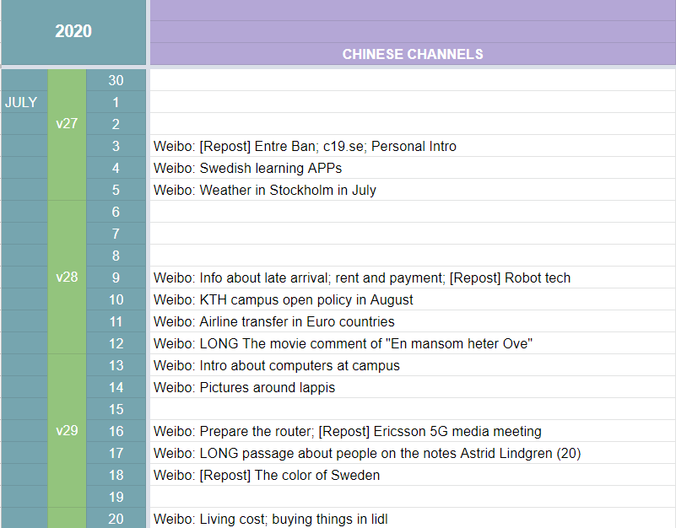

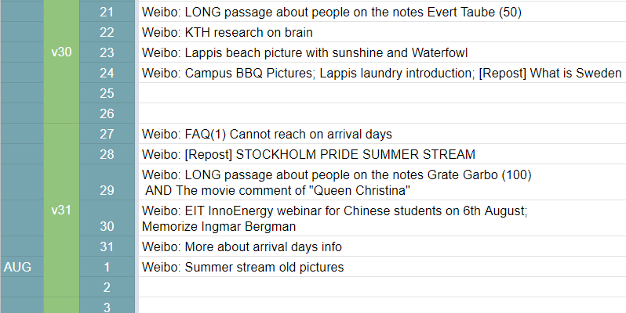

Figure 1 Content Sheet for July

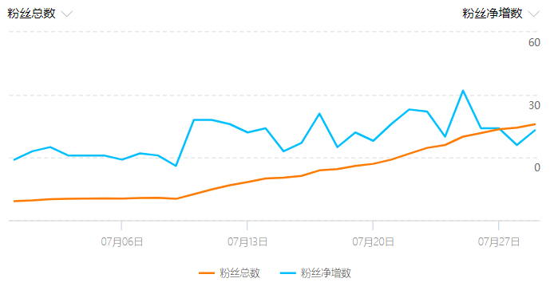

Fans number in total

Fans net increase

Fans number in total

Fans net increase

Figure 2 The number of Weibo fans in July

### Strengths:

LONG passages. I spent much time on them and tried to make the content nice. The topics I chose are more about the Swedish culture.

More posts with real scenery or life pictures.

More interactions with DMs

### Weaknesses:

Be lazy for a while.

Maybe a day 3 posts. Maybe 3 days no post! I guess that is the reason why over 10 people unfollowed on 8th July.

Few contents about KTH academic research.

No short videos! Only words and pictures are not very good.

### August Plan:

Last year pride summer stream pictures

New long passages series for Stockholm museums

Finish the passage series for the figures on the notes.

THS activities pictures!

Plan to add short videos. The content and the editing technique.

More academic research latest info from KTH

Actually, that is a question that puzzles me. **Where can I find this kind of information?**

### Personal feelings

At first, I am not familiar with the working pace. But for now, I know the best pace for me is that everyday I will urge myself to write something. When I have the inspiration, I may write more. But I will not post them all in one day. Another tip for me is that I can read more posts by other related Swedish Weibo accounts and KTH official websites. Then I can transfer them into my style via Photoshop pictures.

August is on the way, hope to perform better and make the account more vivid.

### To do by today:

More about arrival days info. Try to use the similar picture style in FAQ1 on 27th July.

Writing time: 2020/7/31 8:50 AM